BA710

Winter 2023 Case

25 Marks

Due Sunday April 9, 2023

**Deliverable details:**

Complete all questions in this Word document.

Complete the SQL template.

Your source data must be loaded to a schema called BA710case.

Your work data must be loaded to a schema called Work.

Your work tables must include “case_” as a prefix to the table name you choose.

**Premise:**

You work at a company that manufactures and sells electric scooters. You have been told that the pre-orders for the Bat Scooter were initially good, but the orders suddenly dropped by 20%.

Your job is to investigate the situation and test some general hypotheses on why this might have occurred, post hoc.

Since our company headquarters is in Toronto, we need to make sure your dates are stored in Eastern time. The easiest way to do this is to set the time zone in the top of your code:

**/*Set Time Zone*/**

**set time_zone='-4:00';**

**Part 1:**

Complete an analysis of the sales patterns for the Bat scooter. Perform a comparative analysis with the Bat Limited Edition and the Lemon 2013 scooters. Your resulting table for each scooter should have:

1) Daily sales amount

2) Cumulative sales

3) Cumulative sales for a seven day period beginning with the current record and adding the previous 6 records.

4) Percentage change in cumulative sales compared to the same point seven days prior.

**Example Sales Analysis for the Blade Scooter:**

Percentage growth in cumulative_sales from 6/23 to 6/30

Total sales 7/2 – 7/8

Total sales 6/23 – 6/29

Counts/Adds up for each record

Percentage growth in cumulative_sales from 7/8 to 7/1

(63559 – 39899) /39899 = 59.29

**Paste your Bat Sales Analysis table:**

Question: On what date does the cumulative weekly sales growth drop below 10%?

Answer: 2016-12-05

Question: How many days since the launch date did it take for cumulative sales growth

to drop below 10%?

Answer: 56 days

**Paste your Bat Limited Sales Analysis table:**

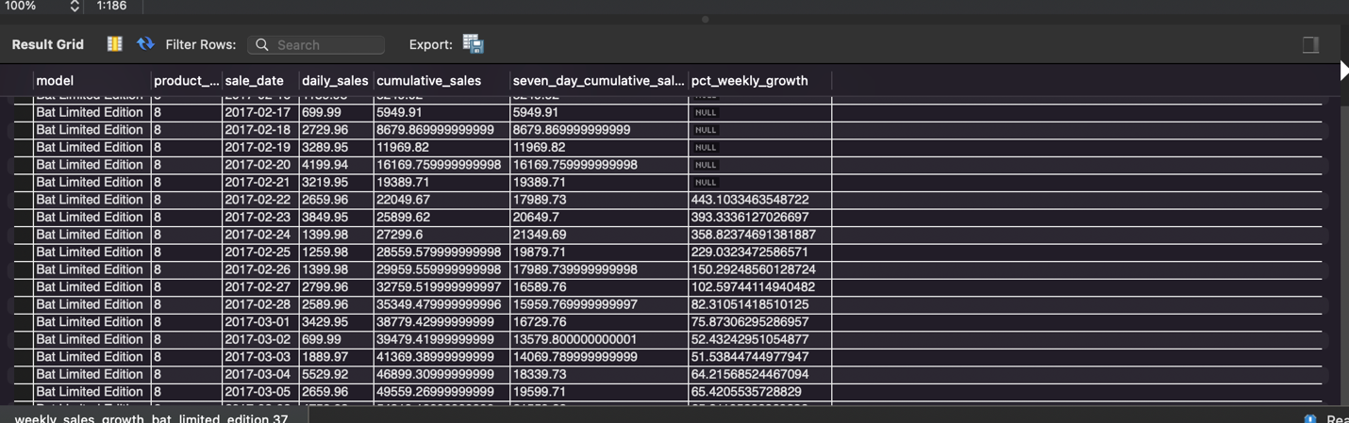

Question: On what date does the cumulative weekly sales growth drop below 10%?

Answer: 2017-04-29

Question: How many days since the launch date did it take for cumulative sales growth

to drop below 10%?

Answer: 73 days

Question: Is there a difference in the behavior in cumulative sales growth

between the Bat edition and the Bat Limited edition? (Make a statement comparing

the growth statistics.)

Answer: Both start off with very high weekly sales growth, above 100% growth weekly. Both the Bat Limited Edition and Bat Scooter weekly growth drops to below 100% 13 days after launch. Both scooters also have similar drops in sales to below 20% 44 and 45 days after launch respectively.

However, the Bat Limited Edition sales growth holds steady above 10% for longer than the Bat Scooter – 73 days for the Bat Limited Edition compared to 56 days for the Bat Scooter. This suggests a sharper drop in sales for the Bat Scooter compared to the Limited Edition.

**Paste your Lemon 2013 Sales Analysis table:**

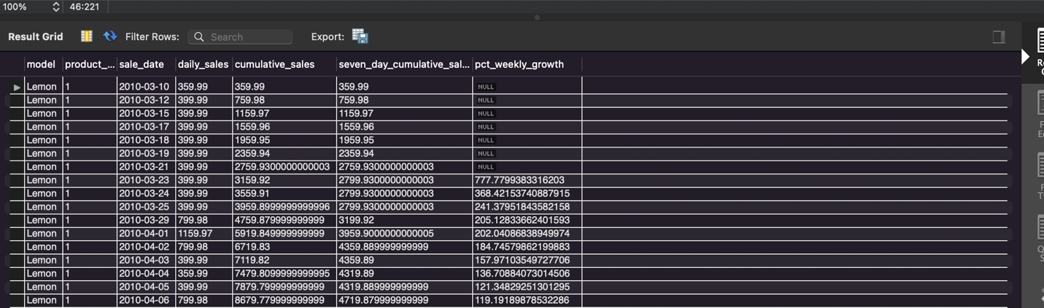

Question: On what date does the cumulative weekly sales growth drop below 10%?

Answer: 2010-06-11

Question: How many days since the launch date did it take for cumulative sales growth

to drop below 10%?

Answer: 93 days

Question: Is there a difference in the behavior in cumulative sales growth

between the Bat edition and the 2013 Lemon edition? (Make a statement comparing

the growth statistics.)

Answer: Again, both the Bat Scooter and the Lemon scooter start off with high weekly sales growths above 100% weekly before dropping below 100%, but the Lemon scooter stays above 100% weekly growth for much longer - 28 days, and also stays above 20% for much longer at 68 days.

However, the sales decline for the Lemon Scooter is much gentler compared to the Bat Scooter. The Lemon Scooter sales growths stays above 100% weekly for longer at 28 days, above 20% 68 days, and above 10% for 93 days after launch.

Analysis of Launch Timing

It is difficult to say whether the launch timing in October might have been the cause for the sharper decline in sales for the Bat Scooter compared to the Bat Limited Edition and Lemon scooter, as there are other factors to consider – such as the different scooter models being released in different years and at different price points.

However, the data seems to suggest that the two scooters released earlier in the year during February and March see a slower decline in sales compared to the Bat Scooter, which released in October.

**Part 2:**

**Coming next week.**